Planning For Drawing Robot

Name, Student ID: Callum Fitzsimons, 20565301

Outline of the Problem to be Solved:

- Store font data
- Set a struct to store the font data in X Y P (line by line)
- Read the font data file
- When X = 999 a new struct of n lines will be created
- Name the struct based on the next value, Y, which relates to the ascii table and set the number of lines within the struct to the next value, P, which will equal n
- Repeat these 2 point until all the font data has been stored in 128 different structs
- Create an array of all the 128 structs
- Setting robot location before starting
- Move the robot to coordinates X = 0, Y = First line (Dependant on the font size)
- Check the word fits on the page
- Scan next word in the input sentence (Characters including the space after it)
- Using a pointer call the character’s font struct for each character in the word
- Call the robots X and Y position on the page
- See if the change in X to the end of the page from the robots position > The word’s change in X (Dependant on the font size fraction the user inputs)
- If yes: Write next word, Else: Set X = 0 and Set Y = to line below (Dependant on font size and what line the robot is on)
- Once the word has been drawn repeat these points for the next word
- Convert character to G-Code and send to robot
- Store new robot position before writing the character (Changes for each character)
- Call the character in the font data using a pointer and the ascii number that has been define to it
- Call the next struct stroke within this letter struct
- Multiply the X and Y coordinates it by the input font size fraction
- Add this line to the stored robot position
- Convert to G-Code and send to the robot
- Repeat the points until the number of struct stroke within the character’s font struct have been drawn
- Repeat points until the word has been drawn
- Setting robot after sentence has been drawn
- Move the robot to the coordinates X = 0, Y = 0
- Errors

- If user has input something incorrectly and error message should appear

Key Data Items
Name | Data type | Rationale
Struct_Stroke | Struct | Sets the data in groups containing 3 values, X Y P
Struct_Font_Character | Struct | A struct for each character that defines the ascii table number and the number of strokes required to draw it
Array_Font_Characters | Array | An array created to allow the Single Stroke Font data to be loaded onto to and is sectioned in 128 sections, each containing the stokes to draw the character
Struct_Word | Struct | Reads the sentence the user has input up to and including the next space and stores this as a struct
Pen_Coordinate_X | Float | The pen’s X coordinate on the page at the time it was stored
Pen_Coordinate_Y | Float | The pen’s Y coordinate on the page at the time it was stored
Font_Size | Int | A number that that the user inputs from 4-10 that defines the size of the character in the sentence
Font_Size_Fraction | Float | The fraction that multiples the coordinates in the font text file by to output the desired size
Word_Length_X | Float | The sum of each character’s and ending X values within a word after it has been scaled by the scaled the font size fraction.
Page_Remaining_X | Float | The difference in X between the pens position at the start of the next word and the end of the page
Line_Space_Y | Float | The space between 2 adjacent writing lines on the page
Robot_GCode | Struct | One line of G-Code that gets sent to the robot and it moves the robot to a specific X and Y coordinate and the set pen up or down for the next move.
Input_Sentence | Array | The sentence that the user types
SingleStrokeFont | Text File | Contains all the strokes required to draw all 128 characters within the ascii table
Word_Buffer | Buffer | Temporal storage for the next word including the space after it

Function Declarations

Void LoadData(Stroke* Struct_Stroke, FontCharacter* Struct_Font_Character, FontCharacter Array_Font_Characters)
Parameters:
Struct_Stroke - Sets the data in groups containing 3 values, X Y P
Struct_Font_Character - A struct for each character within the ascii table that contains all the struct lines that are needed to draw it
Array_Font_Characters - An array created to allow the Single Stroke Font data to be loaded onto to and is sectioned in 128 sections, each containing the stokes to draw the character

Int ReadNextWord(FILE* Input_Sentence, char* Word_Buffer)
Parameters:
Input_Sentence - The sentence that the user types
Word_Buffer - Temporal storage for the next word including the space after it
Returns value: 1, if there are no more letter to scan
0, if there are still more letter to scan

Float WordLength(float Word_Length_X, float Font_Size_Fraction, char* Word_Buffer)
Parameters:
Word_Length_X - The sum of each character’s ending X values within a word after it has been scaled by the scaled the font size fraction.
Font_Size_Fraction - The fraction that multiples the coordinates in the font text file by to output the desired size
Word_Buffer - Temporal storage for the next word including the space after it
Return: Word_Length_X

Int DoesWordFit(float Word_Length_X, float Page_Remaining_X, float Pen_Coordinate_X)
Parameters:
Pen_Coordinate_X - The pen’s X coordinate on the page at the time it was stored
Word_Length_X - The sum of each character’s ending X values within a word after it has been scaled by the scaled the font size fraction.
Page_Remaining_X – The difference in X between the pens position at the start of the next word and the end of the page (Page_Remaining_X = 100 – Pen_Coordinate_X)
Returns value: 0, if word will fit on the page (Page_Remaining_X > Word_Length_X)
1, if word doesn’t fit on page (Page_Remaining_X < Word_Length_X), therefore the NextLine() function is called.

Void NextLine(float Pen_Coordinate_X, float Pen_Coordinate_Y, float Line_Space_Y)
Parameters:
Pen_Coordinate_X - The pen’s X coordinate on the page at the time it was stored
Pen_Coordinate_Y - The pen’s Y coordinate on the page at the time it was stored
Line_Space_Y - The space between 2 adjacent writing lines on the page
Pen_Coordinate_Y = Pen_Coordinate_Y + Line_Space_Y
Pen_Coordinate_X = 0

GCode FontDataToGCode(float Font_Size_Fraction, float Pen_Coordinate_X, float Pen_Coordinate_Y)
Parameters:
Font_Size_Fraction - The fraction that multiples the coordinates in the font text file by to output the desired size
Pen_Coordinate_X - The pen’s X coordinate on the page at the time it was stored
Pen_Coordinate_Y - The pen’s Y coordinate on the page at the time it was stored
Returns: Structs of G-Code that get sent to robot one at a time until all the characters in the word have be sent

Testing Information

Function | Test Case | Test Data | Expected Output
Main() | Verify that the whole program works by completing the drawing of the sentence | ‘This is test line 1  And line 2’ | ‘This is test line 1  And line 2’  Drawn on the page
LoadData() | Verify that the font file loads correctly into an array of memory  Test with empty font data file | Font File: ‘SingleStrokeFont’  Font File:  Error | Array_Font_Characters contains all 128 ASCII characters with correct stroke data stored. All with no file errors.  Print an error message to the user and say the font file is incorrect
ReadNextWord() | Verify that sentence get stored on a buffer word by word  Test with no sentence | Input sentence: ‘Hello my name is Callum’  Input sentence:’’ | Should first store ‘Hello ‘ as a buffer  Should end program as there is no sentence to write
WordLength() | Verify the length of the word is correct assuming  Test with word > 100mm | ‘HELLO ‘  ‘Electromagnetism ‘  (Font_Size =9) | Word_Length_X = 54  Print an error saying word is too long and wont fit on the page
DoesWordFit() | Verify word fits on the page  Test with word that doesn’t fit on the page | ‘HI’  ‘Different’  (Pen_Coordinate_X = 50)  (Font_Size = 8) | Function returns 0  Function returns 1
NextLine() | Verify the coordinates are set to the new line | DoesWordFit(): Returns 1  (Pen_Coordinate_X = 50)  (Pen_Coordinate_Y = -12)  (Font_Size = 6) | Pen_Coordinate_X = 0  Pen_Coordinate_Y = -24
FontDataToGCode() | Verify it converts the stroke to the correct G-Code | Current Line: 0 18 1  (Pen_Coordinate_X = 54)  (Pen_Coordinate_Y = -18)  (Font_Size = 9) | G1 0 18
(The black writing is making sure the code works with correct input)
(The red writing makes sure the code works for different cases and produces and error when input is incorrect)

Flowchart(s)

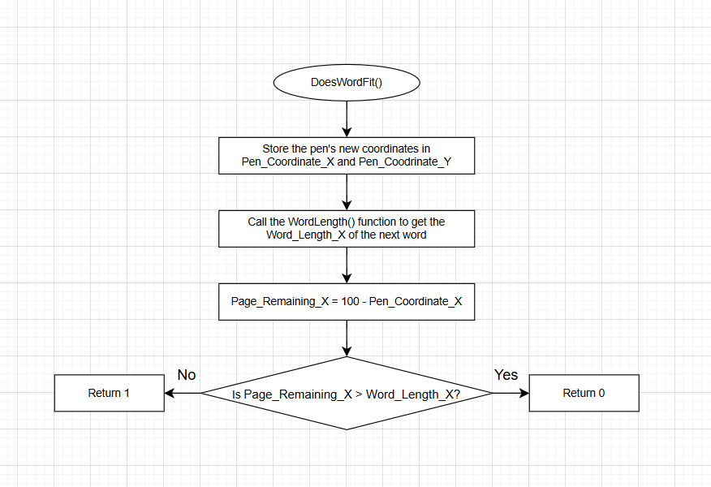
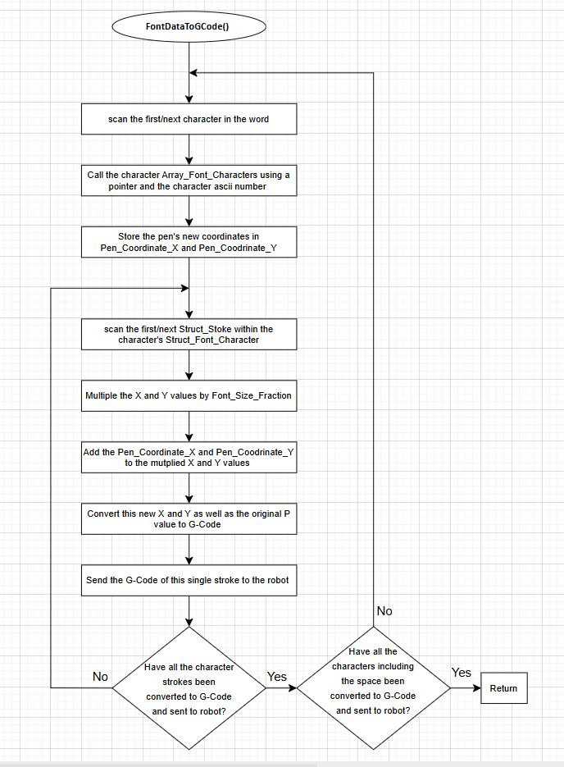

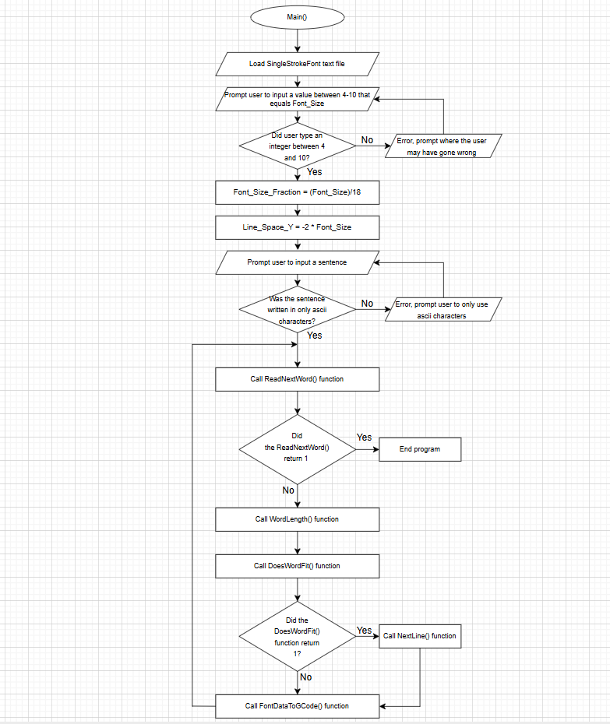

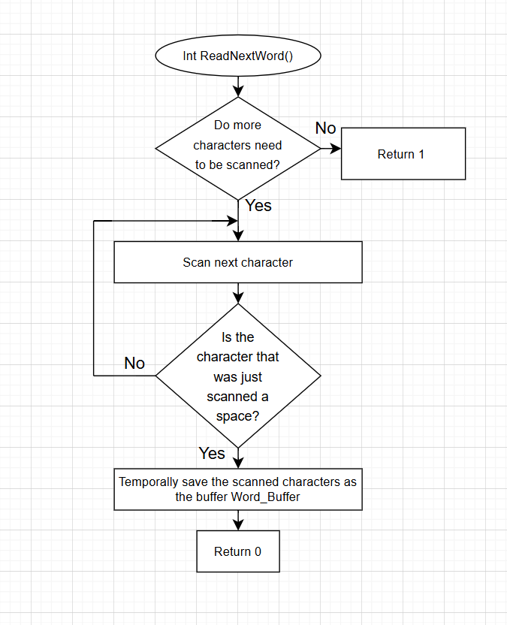

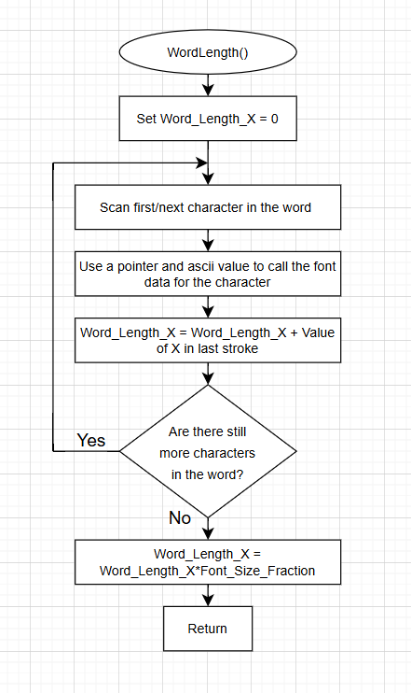

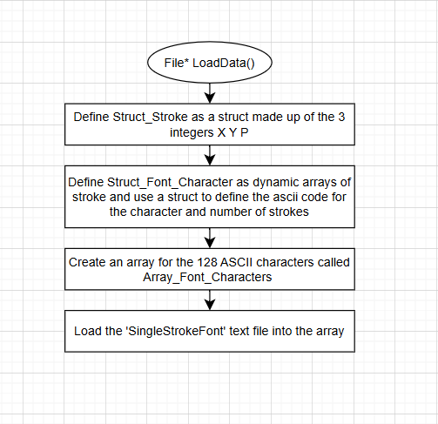

AI Statement

Declaration: I confirm that I have used AI tools appropriately, that the final piece of work that I am submitting has been written entirely by me and is a document based on my initial ideas on how to program the drawing robot

AI assistance was used to:
- Explain programming concepts such as structs, arrays, pointers, and file handling in C.
- Suggest methods for reading and storing font data, processing text input word-by-word, and generating G-Code commands.
- Assist in producing test plans and technical explanations

